第17单元 CMS系统中ElasticSearch应用.md

# 第17单元 CMS系统中ElasticSearch应用

# 【授课重点】

1. CMS系统采用ElasticSearch实现全文搜索
2. 高亮显示

# 【考核要求】

1. CMS系统采用ElasticSearch实现全文搜索
2. 高亮显示

# 【教学内容】

## 17.1 课程导入

### 17.1.1 es整合cms系统准备工作

1. 首先我们把之前启动cms系统所必须的程序启动起来
2. 启动redis

* 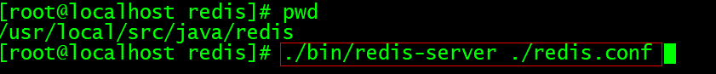

1. 启动我们将要整合进的ES服务(由于多数同学电脑配置跟不上,因此我们用windows版的es)

* 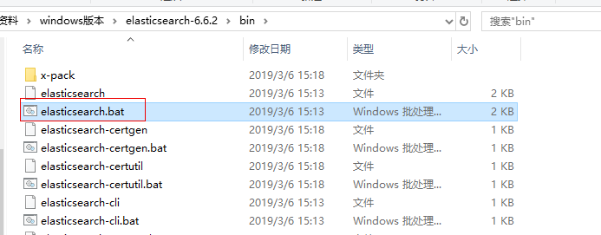
* 启动成功后,我们访问localhost:9200 当浏览器出现如图界面表示启动成功
* 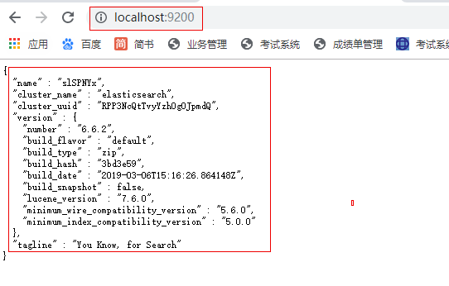

1. 紧接着我们启动head插件

* 如图:
* 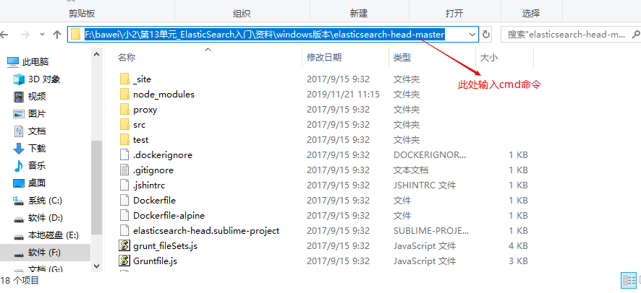
* 下一步:
* 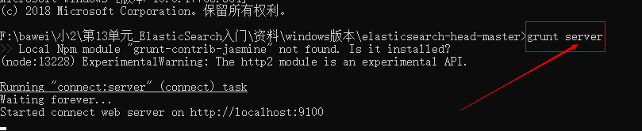
* 我们在浏览器访问:
* localhost:9100 即可访问到!
* 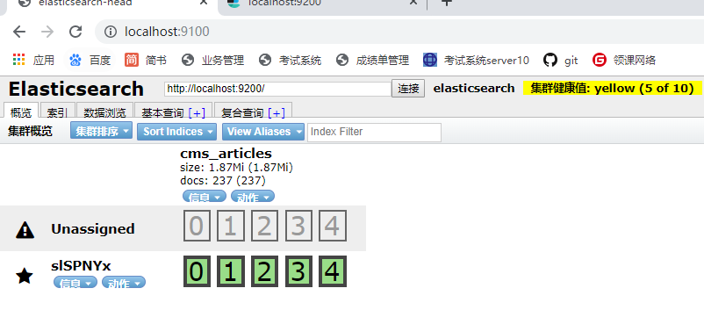

## 17.2 CMS中整合ES

### 17.2.1 编写配置文件

es.xml

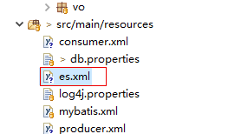

具体代码如下:

<?xml version="1.0" encoding="UTF-8"?>  
<beans xmlns="http://www.springframework.org/schema/beans"  
 xmlns:xsi="http://www.w3.org/2001/XMLSchema-instance"  
 xmlns:elasticsearch="http://www.springframework.org/schema/data/elasticsearch"  
 xmlns:context="http://www.springframework.org/schema/context"  
 xsi:schemaLocation="http://www.springframework.org/schema/beans http://www.springframework.org/schema/beans/spring-beans.xsd  
 http://www.springframework.org/schema/data/elasticsearch http://www.springframework.org/schema/data/elasticsearch/spring-elasticsearch.xsd  
 http://www.springframework.org/schema/context http://www.springframework.org/schema/context/spring-context.xsd">  
   
 <!-- 扫描Dao包，自动创建实例 -->  
 <elasticsearch:repositories base-package="com.gaofei.cms.dao" />  
 <!-- 扫描Service包，创建Service的实体 -->  
 <!-- <context:component-scan base-package="com.bawei.service" /> --> <!-- 配置elasticSearch的连接 -->  
 <!-- es提供了2个端口号:9200和9300  
 9200:对浏览器暴露的端口号  
 9300:是对java编程需要操作es所暴露的端口号  
 -->  
 <elasticsearch:transport-client id="client"  
 cluster-nodes="localhost:9300" /> <!-- spring data elasticSearcheDao 必须继承 ElasticsearchTemplate -->  
   
 <bean id="elasticsearchTemplate"  
 class="org.springframework.data.elasticsearch.core.ElasticsearchTemplate">  
 <constructor-arg name="client" ref="client"></constructor-arg>  
 </bean>  
   
</beans>

### 17.2.2 声明实体类注解

代码如下:

//@Document 文档对象 （索引信息、文档类型 ）  
@Document(indexName="cms_articles",type="article")   
public class Article implements Serializable{  
 /**  
 * @fieldName: serialVersionUID  
 * @fieldType: long  
 * @Description: TODO  
 */  
 private static final long serialVersionUID = 1L;  
 @Id  
 private Integer id;  
// 1.是否索引:是否建立索引  
 // 2.分词方式:是用的ik分词器的智能分词方式  
 // 3.是否存储到索引库  
 // 4.搜索框里的词,是否分词  
 @Field(index=true,analyzer="ik_smart",store=true,searchAnalyzer="ik_smart",type = FieldType.text)  
 private String title;  
   
 private String picture;  
  
 private Integer channelId;  
  
 private Integer categoryId;  
  
 private Integer userId;  
   
 private User user;//文章发布人  
   
 private List<ArticleVO> voList;//图片集  
   
 private String terms;//文章标签  
   
   
 private String original;//文章来源  
 private String keywords;//关键词  
   
   
  
 public String getTerms() {  
 return terms;  
 }  
  
 public void setTerms(String terms) {  
 this.terms = terms;  
 }  
  
 public String getOriginal() {  
 return original;  
 }  
  
 public void setOriginal(String original) {  
 this.original = original;  
 }  
  
 public String getKeywords() {  
 return keywords;  
 }  
  
 public void setKeywords(String keywords) {  
 this.keywords = keywords;  
 }  
  
 private Integer hits;  
  
 private Integer hot;  
  
 private Integer status;  
  
 private Integer deleted;  
  
 private Date created;  
  
 private Date updated;  
   
 private Integer contentType;  
   
   
  
 public Integer getContentType() {  
 return contentType;  
 }  
  
 public void setContentType(Integer contentType) {  
 this.contentType = contentType;  
 }  
  
 public List<ArticleVO> getVoList() {  
 return voList;  
 }  
  
 public void setVoList(List<ArticleVO> voList) {  
 this.voList = voList;  
 }  
  
 public Integer getId() {  
 return id;  
 }  
  
 public void setId(Integer id) {  
 this.id = id;  
 }  
  
 public String getTitle() {  
 return title;  
 }  
  
 public void setTitle(String title) {  
 this.title = title == null ? null : title.trim();  
 }  
  
 public String getPicture() {  
 return picture;  
 }  
  
 public void setPicture(String picture) {  
 this.picture = picture == null ? null : picture.trim();  
 }  
  
 public Integer getChannelId() {  
 return channelId;  
 }  
  
 public void setChannelId(Integer channelId) {  
 this.channelId = channelId;  
 }  
  
 public Integer getCategoryId() {  
 return categoryId;  
 }  
  
 public void setCategoryId(Integer categoryId) {  
 this.categoryId = categoryId;  
 }  
  
 public Integer getUserId() {  
 return userId;  
 }  
  
 public void setUserId(Integer userId) {  
 this.userId = userId;  
 }  
  
 public Integer getHits() {  
 return hits;  
 }  
  
 public void setHits(Integer hits) {  
 this.hits = hits;  
 }  
  
 public Integer getHot() {  
 return hot;  
 }  
  
 public void setHot(Integer hot) {  
 this.hot = hot;  
 }  
  
 public Integer getStatus() {  
 return status;  
 }  
  
 public void setStatus(Integer status) {  
 this.status = status;  
 }  
  
 public Integer getDeleted() {  
 return deleted;  
 }  
  
 public void setDeleted(Integer deleted) {  
 this.deleted = deleted;  
 }  
  
 public Date getCreated() {  
 return created;  
 }  
  
 public void setCreated(Date created) {  
 this.created = created;  
 }  
  
 public Date getUpdated() {  
 return updated;  
 }  
  
 public void setUpdated(Date updated) {  
 this.updated = updated;  
 }  
  
 public User getUser() {  
 return user;  
 }  
  
 public void setUser(User user) {  
 this.user = user;  
 }  
}  
  
public class ArticleWithBLOBs extends Article implements Serializable{  
 /**  
 * @fieldName: serialVersionUID  
 * @fieldType: long  
 * @Description: TODO  
 */  
 private static final long serialVersionUID = 1L;  
 @Field(index=true,analyzer="ik_smart",store=true,searchAnalyzer="ik_smart",type = FieldType.text)  
 private String content;  
  
 private String summary;  
  
 public String getContent() {  
 return content;  
 }  
  
 public void setContent(String content) {  
 this.content = content == null ? null : content.trim();  
 }  
  
 public String getSummary() {  
 return summary;  
 }  
  
 public void setSummary(String summary) {  
 this.summary = summary == null ? null : summary.trim();  
 }  
}

### 17.2.3 编写dao层接口

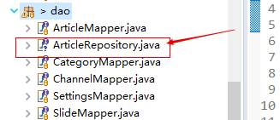

//继承完了之后,具备了CRUD的操作  
public interface ArticleRepository extends ElasticsearchRepository<ArticleWithBLOBs, Integer> {  
 //实现复杂查询  
 //按照标题查询,方法名称一定要按照规则写  
 List<ArticleWithBLOBs> findByTitle(String key);  
   
 //按照标题或者内容查询,方法名称一定要按照规则写  
 List<ArticleWithBLOBs> findByTitleOrContent(String title,String content);  
   
}

### 17.2.3 让spring容器加载es配置

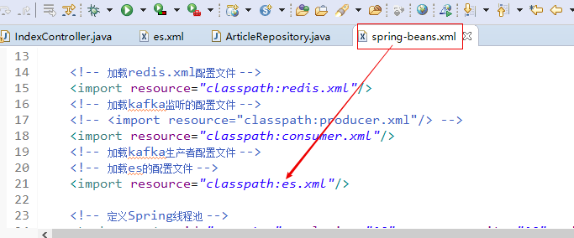

## 17.3 编写Controller层代码

/**  
 * es搜索的方法  
 *   
 */  
 @RequestMapping("search")  
 public String search(String key, Model model, @RequestParam(defaultValue = "1") Integer page,  
 @RequestParam(defaultValue = "2") Integer pageSize) {  
 long start = System.currentTimeMillis();  
  
// List<ArticleWithBLOBs> list = articleRepository.findByTitle(key);  
 // 高亮查询想要的结果  
 AggregatedPage<?> selectObjects = ESUtils.selectObjects(elasticsearchTemplate, Article.class, page, pageSize,  
 new String[] { "title" }, key);  
 List<?> list = selectObjects.getContent();  
  
 long end = System.currentTimeMillis();  
 System.err.println("搜索耗时:" + (end - start));  
 System.err.println(key);  
// System.err.println(list.get(0).getTitle());  
 String pages = PageUtil.page(page, (int) selectObjects.getTotalElements(), "/search?key=" + key, pageSize);  
  
 model.addAttribute("pages", pages);  
 model.addAttribute("hotArticles", list);  
 return "index/index";  
 }

**关于ESutil参见下面代码:**

// 查询操作  
 public static AggregatedPage<?> selectObjects(ElasticsearchTemplate elasticsearchTemplate, Class<?> clazz, Integer page,  
 Integer rows, String fieldNames[], String value) {  
 AggregatedPage<?> pageInfo = null;  
 // 创建Pageable对象  
 Pageable pageable = PageRequest.of(page - 1, rows, Sort.by(Sort.Direction.ASC, "id"));  
 //查询对象  
 SearchQuery query = null;  
 //查询条件高亮的构建对象  
 QueryBuilder queryBuilder = null;  
   
 if (value != null && !"".equals(value)) {  
 // 高亮拼接的前缀与后缀  
 String preTags = "<font color=\"red\">";  
 String postTags = "</font>";  
  
 // 定义创建高亮的构建集合对象  
 HighlightBuilder.Field highlightFields[] = new HighlightBuilder.Field[fieldNames.length];  
  
 for (int i = 0; i < fieldNames.length; i++) {  
 // 这个代码有问题  
 highlightFields[i] = new HighlightBuilder.Field(fieldNames[i]).preTags(preTags).postTags(postTags);  
 }  
  
 // 创建queryBuilder对象  
 queryBuilder = QueryBuilders.multiMatchQuery(value, fieldNames);  
 query = new NativeSearchQueryBuilder().withQuery(queryBuilder).withHighlightFields(highlightFields)  
 .withPageable(pageable).build();  
  
 pageInfo = elasticsearchTemplate.queryForPage(query, clazz, new SearchResultMapper() {  
  
 @Override  
 public <T> AggregatedPage<T> mapResults(SearchResponse response, Class<T> clazz, Pageable pageable) {  
  
 List<T> content = new ArrayList<T>();  
 long total = 0l;  
  
 try {  
 // 查询结果  
 SearchHits hits = response.getHits();  
 if (hits != null) {  
 //获取总记录数  
 total = hits.getTotalHits();  
 // 获取结果数组  
 SearchHit[] searchHits = hits.getHits();  
 // 判断结果  
 if (searchHits != null && searchHits.length > 0) {  
 // 遍历结果  
 for (int i = 0; i < searchHits.length; i++) {  
 // 对象值  
 T entity = clazz.newInstance();  
  
 // 获取具体的结果  
 SearchHit searchHit = searchHits[i];   
  
 // 获取对象的所有的字段  
 Field[] fields = clazz.getDeclaredFields();  
  
 // 遍历字段对象  
 for (int k = 0; k < fields.length; k++) {  
 // 获取字段对象  
 Field field = fields[k];  
 // 暴力反射  
 field.setAccessible(true);  
 // 字段名称  
 String fieldName = field.getName();  
 if (!fieldName.equals("serialVersionUID")&&!fieldName.equals("user")) {  
 HighlightField highlightField = searchHit.getHighlightFields()  
 .get(fieldName);  
 if (highlightField != null) {  
 // 高亮 处理 拿到 被<font color='red'> </font>结束所包围的内容部分  
 String value = highlightField.getFragments()[0].toString();  
 // 注意一下他是否是 string类型  
 field.set(entity, value);  
 } else {  
 //获取某个字段对应的 value值  
 Object value = searchHit.getSourceAsMap().get(fieldName);  
 System.out.println(value);  
 // 获取字段的类型  
 Class<?> type = field.getType();  
 if (type == Date.class) {  
 // bug  
 if(value!=null) {  
 field.set(entity, new Date(Long.valueOf(value + "")));  
 }  
 } else {  
 field.set(entity, value);  
 }  
 }  
 }  
 }  
  
 content.add(entity);  
 }  
 }  
 }  
 } catch (Exception e) {  
 e.printStackTrace();  
 }  
  
 return new AggregatedPageImpl<>(content, pageable, total);  
 }  
 });  
  
 } else {  
 // 没有查询条件的的时候，获取es中的全部数据 分页获取  
 query = new NativeSearchQueryBuilder().withPageable(pageable).build();  
 pageInfo = elasticsearchTemplate.queryForPage(query, clazz);  
 }  
  
  
 return pageInfo;  
 }

## 17.4 编写前端代码

<!-- 搜索框：在专业高级二学完ElasticSearch后实现 -->  
 <form action="/search" class="form-inline">  
 <div class="input-group">  
 <input type="text" name="key" class="form-control"  
 placeholder="输入关键字..." aria-label="key"  
 aria-describedby="basic-addon1">  
 <div class="input-group-prepend">  
 <button class="input-group-btn btn btn-outline-primary"  
 id="basic-addon1">搜索</button>  
 </div>  
 </div>  
 </form>

此时我们就已经利用es实现的搜索

**注意:从es中查询文章的数据,我们还没有.于是我们要写一个测试类从mysql中查询文章数据,然后导入到es索引库**

@RunWith(SpringJUnit4ClassRunner.class)  
@ContextConfiguration(locations="classpath:spring-beans.xml")  
public class ImportMysqlDB2Es {  
  
 @Autowired  
 ArticleMapper articleMapper;  
 @Autowired  
 ArticleRepository articleRepository;  
 //1.解决com.fasterxml.jackson.core.Versioned  
 // 1.1到pom里粘贴解决冲突的依赖  
 //2.到pom里修改<validator.version>5.1.0.Final</validator.version>  
 //3.到pom里修改jetty版本: 9.4.9.v20180320  
 @Test  
 public void testImport() {  
 List<ArticleWithBLOBs> selects = articleMapper.selects(null);  
 System.out.println(selects);  
 articleRepository.saveAll(selects);  
 }  
}

导入成功,效果如图:

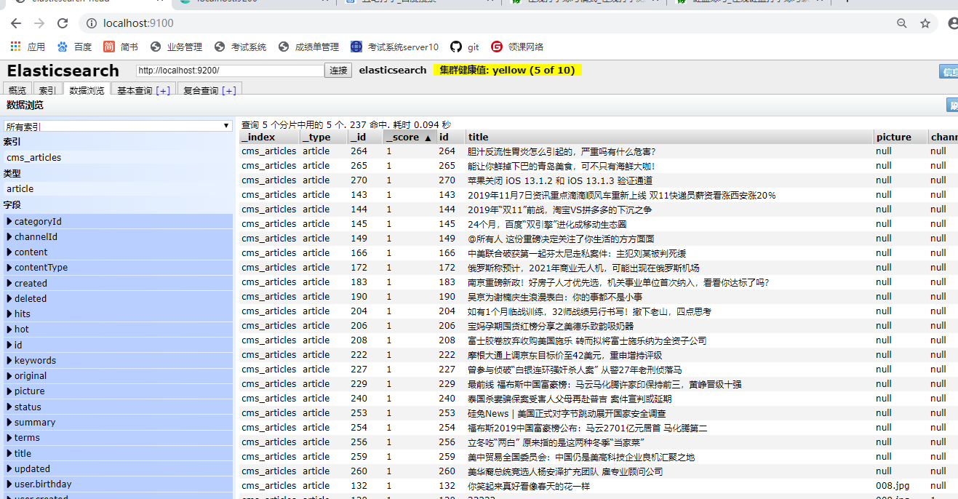

最终我们就可以实现搜索的高亮显示!!

如图:

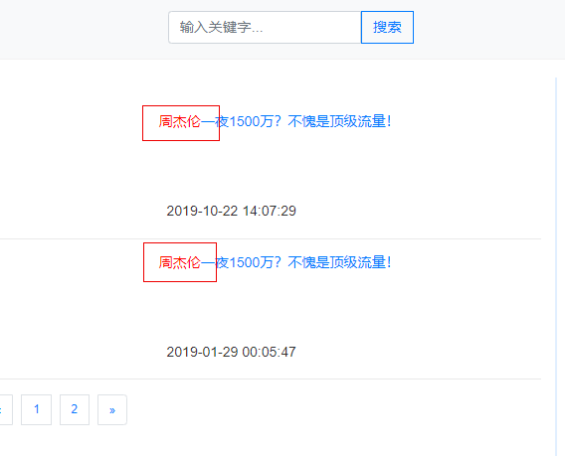

# 课堂练习:

## 1.完成上课cms整合es的操作,实现高亮显示(40分钟)